Transient state-applications to be solved

tzp. 1.Let’s consider the circuit from Fig. tzp.1, where the values of the circuit elements are R = 10 Ω, R₁ = 30 Ω, L = 0.1 mH, and the value of the constant voltage source is E = 120 V. If at the moment t = 0 the switch K is closed, shortcutting the resistor R₁, determine the time variation of the current through the coil and the voltage at its terminals.
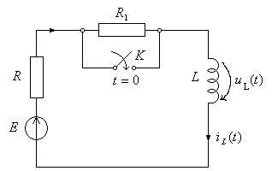
Fig. tzp.1
R: $i_{L}\left(t\right)=\text{12}⋅\left(1+\frac{3}{4}⋅e^{−\text{100} t}\right)$A, $u_{L}\left(t\right)=−9⋅e^{−\text{100} t}$V.

tzp. 2.Let’s consider the circuit from Fig. tzp.2, where the values of the circuit elements areR₁ = R₂ = 3 Ω and C = 1/3 mF, and the values of the constant voltage source isE = 24 V. If at the momentt = 0 the switch K is open, determine the time variation of the currents in the circuit and of the voltage on the capacitor after switching.
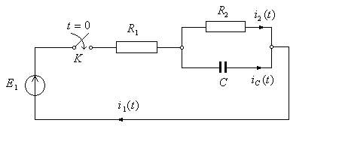
Fig. tzp.2
R: $i_{1}\left(t\right)=4⋅\left( 1+e^{−\text{2000} t}\right) A$; $i_{2}\left(t\right)=4⋅\left( 1−e^{−\text{2000} t}\right) A$; $i_{C}\left(t\right)=8⋅e^{−\text{2000} t} A$;
$u_{C}\left(t\right)=\text{12}⋅\left(1−e^{−\text{2000} t}\right) V$

tzp. 3. Let’s consider the circuit from Fig. tzp.3, where the values of the circuit elements are R,L,C In the three cases: a) R = 250 Ω, L = 2/3 mH, C = 2 μF; b) R = 100 Ω, L = 40 mF, C = 1μF; c) R = 100Ω, L = 40mF C = 5μF. In the three cases, the value of the constant voltage source is E = 250 V. If at the moment t = 0 the switch K is closed, determine the time variation of the voltage on the capacitor for the three cases.
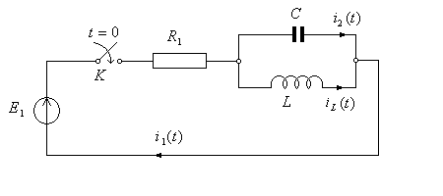
Fig. tzp.3
R: a) $u_{c}\left(t\right)=\text{500}⋅\left(e^{−\text{500} t}−e^{−\text{1500} t}\right) V$; b) $u_{c}\left(t\right)=2,5⋅{\text{10}}^{6} t e^{−\text{500} t} V$
c) $u_{c}\left(t\right)=\text{250} e^{−\text{1000} t}\text{sin}\text{2000} t V$

tzp. 4. The circuit from Fig. tzp.4 is under steady-state with the switch K closed. The values of the constant voltage sources are E₁ = 40 V and E₂ = 20 V, resistors R₁ = 3Ω, R₂ = 1Ω and capacitance C = 4/3 mF. Let’s determine the time variation of the voltage on the capacitor and the current through R_{1,} after opening K.
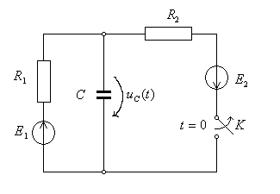
Fig. tzp.4
R: $u_{C}\left(t\right)=\text{40}−\text{45}⋅e^{−\text{250} t} V$; $i_{1}\left(t\right)=\text{15}⋅e^{−\text{250} t} A$

tzp. 5.Let’s consider the circuit from Fig. tzp.5, where the values of the circuit elements are: R₁ = R₂ = 2 Ω, L₁ = 1 mH, L₂ = 2 mH, and the value of the constant voltage source is E = 6V. At the momentt = 0, the switch K₁ is closed and at the moment t = t₁, with t₁ big enough to reach the steady state, the switch K₂ is closed too. Let’s determine the time variation of the currents through the coils for the following cases:
a) $t∈\left(0, t_{1}\right)$; b) $t∈\left(t_{1}, ∞\right)$.
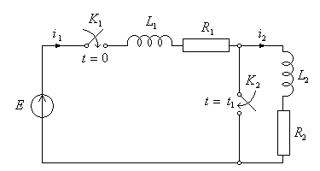
Fig. tzp.5
R: a) $t∈\left(0, t_{1}\right)$ : $i_{1}\left(t\right)=i_{2}\left(t\right)=2⋅\left(1−e^{−\text{1000} t}\right) A$
b) $t∈\left(t_{1}, ∞\right)$ : $i_{1}\left(t\right)=3⋅\left(1−\frac{1}{3}⋅e^{−\text{2000} t}\right) A$; $i_{2}\left(t\right)=2⋅e^{−\text{500} t} A$

tzp. 6.Let’s consider the circuit from Fig. tzp.6. Let’s determine the time variation of the voltage on the capacitor C, knowing that, after beeing charged under the E, is connected at the terminals of a parallel RL circuit , switching K from a to b.
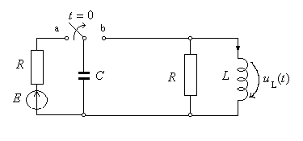
Fig. tzp.6
R: $u_{C}\left(t\right)={\text{Ee}}^{−α t}\left(\text{ch} β t−\frac{α}{β}\text{sh} β t\right)$ unde $α=\frac{1}{2R C}$; $β=\sqrt{α^{2}−\frac{1}{L C}}$

tzp. 7. The circuits from the Fig. tzp.7 is described by the relation $R=\sqrt{L/C}$. When closing K the circuit is at the moment t=0 with the voltage $u_{b}\left(t\right)=U_{0}\left(1−e^{−α t}\right)$. Let’s determine the main current and the currents of the circuit. The capacitors are not initially charged.

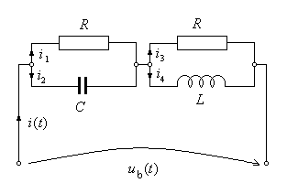
Fig. tzp.7
R:. $i\left(t\right)=\frac{U_{0}}{R}\left(1−e^{−α t}\right)$; $i_{4}\left(t\right) = i_{1}\left(t\right)=\frac{U_{0}}{R}⋅\left(1+\frac{α e^{−ω_{0} t}−ω_{0}e^{−α t}}{ω_{0}−α}\right)$
$i_{2}\left(t\right)=i_{3}\left(t\right)=\frac{U_{0} α}{R}⋅\frac{e^{−α t}−e^{−ω_{0} t}}{ω_{0}−α} , \text{unde} ω_{0}=\frac{R}{L}$

tzp. 8.Let’s consider the circuit from Fig. tzp.8, where the values of the circuit elements are R = 10 Ω, L = 100 mH and C = 1 mF, and the value of the constant voltage source is E = 10 V. If at the moment t = 0 the switch K is closed, determine the time variation of the current through the coil and of the voltage on the capacitor after switching.
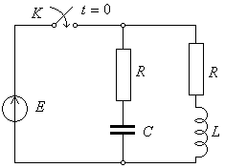
Fig. tzp.8
R: i_{L}(t) = 1– e ^{– 100 t} A; u_{C}(t) = 10(1 – e ^{– 100 t} ) V.

tzp. 9.Let’s consider the circuit from Fig. tzp.9, where the values of the circuit elements are R = 10 Ω, L = 100 mH and C = 1 mF, and the value of the constant voltage source is E = 10 V. If at the moment t = 0 the switch K is open, determine the time variation of the current through the coil and of the voltage on the capacitor after switching.
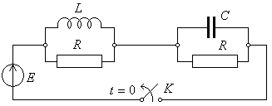
Fig. tzp.9
R: i_{L}(t) = e ^{– 100 t} A; u_{C}(t) = 10e ^{– 100 t} V.

tzp. 10.Let’s consider the circuit from Fig. tzp.10, where the values of the circuit elements are R = 2 Ω, L = 2 mH and C = 250 μF, The values of the constant voltage sources are E = 10 V, respectively E’ = 6 V. If at the moment t = 0 the switch K is closed, determine the time variation of the current through the coil and of the voltage on the capacitor after switching.
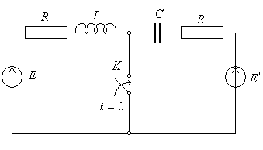
Fig. tzp.10
R: i_{L}(t) = 3(1–e ^{– 1000 t} ) A; u_{C}(t) = 6(2 – e ^{– 2000 t} ) V.

tzp. 11.Let’s consider the circuit from Fig. tzp.11, where the values of the circuit elements are R = 30 Ω, L = 0.5 H and C = 800 μF, and the values of the constant voltage source is E = 10 V. If at the moment t = 0 the switch K is closed, determine the time variation of the current through the coil and of the voltage on the capacitor after switching.
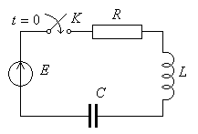
Fig. tzp.11
R: i_{L}(t) = 9.6e ^{– 30 t} sin(50t) A; u_{C}(t) = 120 – 40e^{–30t}[3cos(50t) + 5sin(50t)] V.

tzp. 12.Let’s consider the circuit from Fig. tzp.12, where the values of the circuit elements are R = 10 Ω, L = 1 H and C = 10 mF, and the value of the constant voltage source is E = 100 V. If at the momentt = 0 the switch K is open, determine the time variation of the current through the coil and of the voltage on the capacitor after switching.
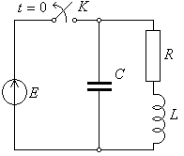
Fig. tzp.12
R: $i_{L}(t)=\text{100}e^{−5t}\text{cos}\left(5\sqrt{3}t+π/3\right)$ A; $u_{C}(t)=\text{200}e^{−5t}\text{cos}\left(5\sqrt{3}t−π/3\right)$ V.

tzp. 13.Let’s consider the circuit from Fig. tzp.13, where the values of the circuit elements are R = 200 Ω, r = 800 Ω, L = 1 H and C = 10 μF, and the value of the constant voltage source is E = 200 V. If at the moment t = 0 the switch K is open, determine the time variation of the current through the coil and of the voltage on the capacitor after switching.
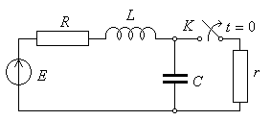
Fig. tzp.13
R: $i_{L}(t)=−0\text{.}\text{23}e^{−\text{100}t}\text{cos}\left(\text{300}t−{\text{59}}^{0}\right)$ A; $u_{C}(t)=\text{200}+\text{66}\text{.}6e^{−\text{100}t}\text{cos}\left(\text{300}t−{\text{37}}^{0}\right)$ V.

tzp. 14.Let’s consider the circuit from Fig. tzp.14, where the values of the circuit elements are R = 10 Ω, L = 20 mH and C = 200 μF, and the value of the constant voltage source is E = 100 V. If at the moment t = 0 the switch K is closed, determine the time variation of the current through the coil and of the voltage on the capacitor after switching.
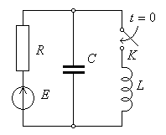
Fig. tzp.14
R: $i_{L}(t)=\text{10}+\frac{\text{20}}{\sqrt{3}}e^{−\text{250}t}\text{sin}\left(\text{250}\sqrt{3}t−\frac{π}{3}\right)$ A; $u_{C}(t)=\frac{\text{200}}{\sqrt{3}}e^{−\text{250}t}\text{sin}\left(\text{250}\sqrt{3}t+\frac{π}{3}\right)$ V.

tzp. 15.Let’s consider the circuit from Fig. tzp.15, where the values of the circuit elements are R₁ = R₂ = 100 Ω, L = 1 H and C = 100 μF, and the value of the constant voltage source is E = 100 V. If at the moment t = 0 the switch K is closed, determine the time variation of the current through the coil and of the voltage on the capacitor after switching.
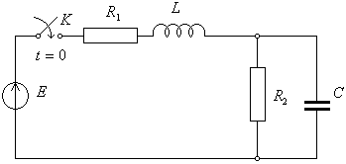
Fig. tzp.15
R: $i_{L}(t)=\frac{1}{2}+\sqrt{2}e^{−\text{1000}t}\text{cos}\left(\text{100}t+\frac{5π}{4}\right)$ A; $u_{C}(t)=\text{50}+\text{50}\sqrt{2}e^{−\text{1000}t}\text{cos}\left(\text{100}t+\frac{3π}{4}\right)$ V

tzp. 16.Let’s consider the circuit from Fig. tzp.16, where the values of the circuit elements are R₁ = 200 Ω, R₂ = 100 Ω, L = 1 H and C = 200 μF, and the value of the constant voltage source is E = 300 V. If at the moment t = 0 the switch K is closed, determine the time variation of the current through the coil and of the voltage on the capacitor after switching.
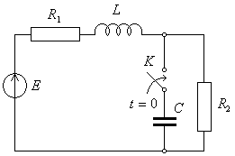
Fig. tzp.16
R: $i_{L}(t)=1+2e^{−\text{100}t}−2e^{−\text{150}t}$A; $u_{C}(t)=\text{100}−\text{200}e^{−\text{100}t}+\text{100}e^{−\text{150}t}$V

tzp. 17.Let’s consider the circuit from Fig. tzp.17, where the values of the circuit elements are R = 2 Ω, L = 3/2 H and C = 1/3 F, and the values of the constant voltage source is E = 6 V. If at the momentt = 0 the switch K is closed, determine the time variation of the current through the coil and of the voltage on the capacitor after switching.
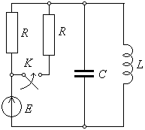
Fig. tzp. 17
R: i_{L}(t) = 4 – 4e ^{– t} + 2e ^{– 2 t} A; u_{C}(t) = 6(e ^{– t} – e ^{– 2 t}) V.

tzp. 18.Let’s consider the circuit from Fig. tzp.18, where the values of the circuit elements are R = 1 Ω, L = 2 H and C = 1 F, and the value of the constant voltage source is E = 6 V. If at the momentt = 0 the switch K is closed, determine the time variation of the current through the coil and of the voltage on the capacitor after switching.
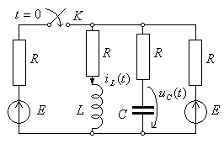
Fig. tzp. 18
R: i_{L}(t) = 4 + 2e ^{–3 t} – 3e ^{– 2 t} A; u_{C}(t) = 4 – 10e ^{– 3 t} + 9e ^{– 2 t} V.

tzp. 19.Let’s consider the circuit from Fig. tzp.19, where the values of the circuit elements are R = 1 Ω, L = 3/2 H and C = 1/3 F, and the value of the constant voltage source is E = 6 V. If at the momentt = 0 the switch K is closed, determine the time variation of the current through the coil and of the voltage on the capacitor after switching.
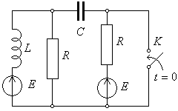
Fig. tzp. 19
R: i_{L}(t) = 6 + 4e ^{– t} – 4e ^{– 2 t} A; u_{C}(t) = 6e ^{– t} – 12e ^{– 2 t} V.

tzp. 20.Let’s consider the circuit from Fig. tzp.20, where the values of the circuit elements are R₁ = 1 Ω, R₂ = 2 Ω, R₃ = 5/4 Ω, L = 1 H and C = 1/4 F, and the value of the constant voltage source is E₁ = 12 V, E₂ = 3 V. If at the momentt = 0 the switch K is open, determine the time variation of the current through the coil and of the voltage on the capacitor after switching.
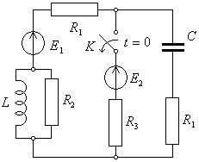
Fig. tzp. 20
R: $i_{L}(t)=4−\left(4+\frac{\text{15}}{4}t\right) e^{−\frac{3t}{2}}$ A; $u_{C}(t)=8+\left(4−\frac{\text{15}}{2}t\right) e^{−\frac{3t}{2}}$ V

tzp. 21.Let’s consider the circuit from Fig. tzp.21, where the values of the circuit elements areR = 0.4 Ω, L = 1/3 H and C = 1/2 F, and the values of the constant voltage source is E = 4 V. If at the moment t = 0 the switch K is closed, determine the time variation of the current through the coil and of the voltage on the capacitor after switching.
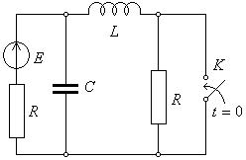
Fig. tzp. 21
R: i_{L}t) = 10 – 9e ^{–2 t} + 4e^{–3 t} A; u_{C}(t) = 6e ^{– 2 t} – 4e ^{– 3 t} V.

tzp. 22.Let’s consider the circuit from Fig. tzp.22, where the values of the circuit elements are R = 10 Ω, L = 1/10 H and C = 100 μF, and the values of the constant voltage source is E = 120 V. If at the momentt = 0 the switch K is closed, determine the time variation of the current through the coil and of the voltage on the capacitor after switching.
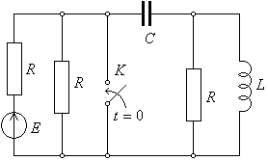
Fig. tzp. 22
R: i_{L}(t) = – 1.6e ^{– 200 t} + 1.6e ^{– 800 t} A, u_{C}(t) = – 20e ^{– 200 t} + 80e ^{– 800 t} V.

tzp.23.Let’s consider the circuit from Fig. tzp23, where the values of the circuit elements are R = 2 Ω, L = 2 mH and C = 250 μF, and the values of the voltage sources are E = 10 V, respectively E’ = 6 V. If at the moment t = 0 the switch K is open, determine the time variation of the current through the coil and of the voltage on the capacitor after switching.
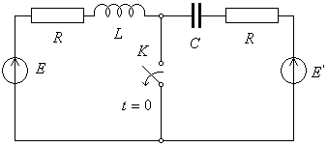
Fig. tzp. 23
R:$i_{L}(t)=0\text{.}\text{75}e^{−\text{1000}t}\left(5\text{sin}({\text{10}}^{3}t)−\text{cos}({\text{10}}^{3}t)\right)$; $u_{C}(t)=6+6e^{−\text{1000}t}\left(0\text{.}5\text{sin}({\text{10}}^{3}t)+\text{cos}({\text{10}}^{3}t)\right)$

tzp. 24.Let’s consider the circuit from Fig. tzp.24, where the values of the circuit elements areR = 1 Ω, R₁ = 5/4 Ω, R₂ = 2 Ω, L = 1 mH and C = 0.25 mF, and the values of the voltage sources are E = 12 V, respectively E₁ = 3 V. If at the moment t = 0 the switch K is open, determine the time variation of the current through the coil and of the voltage on the capacitor after switching.
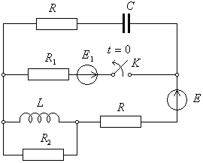
Fig. tzp. 24
R: $i_{L}(t)=e^{−\text{1000}t}\left(4\text{cos}({\text{10}}^{3}t)+2\text{sin}({\text{10}}^{3}t)\right)$ ; $u_{C}(t)=\text{12}+e^{−\text{1000}t}\left(8\text{sin}({\text{10}}^{3}t)−4\text{cos}({\text{10}}^{3}t)\right)$

tzp. 25.Let’s consider the circuit from Fig. tzp.25, where the values of the circuit elements are R = 5 Ω, L = 62.5 mH and C = 100 μF, and the value of the voltage source is E = 90 V. If at the moment t = 0 the switch K is closed, determine the time variation of the current through the coil and of the voltage on the capacitor after switching.
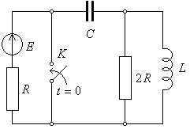
Fig. tzp. 25
R: $i_{L}(t)=−2\text{.}4e^{−\text{200}t}+2\text{.}4e^{−\text{800}t}$; $u_{C}(t)=−\text{30}e^{−\text{200}t}+\text{120}\text{exp}e^{−\text{800}t}$

tzp. 26.Let’s consider the circuit from Fig. tzp.26, where the values of the circuit elements areR = 5 Ω, L = 62.5 mH and C = 100 μF, and the value of the voltage source is E = 100 V. If at the moment t = 0 the switch K is closed, determine the time variation of the current through the coil and of the voltage on the capacitor after switching.
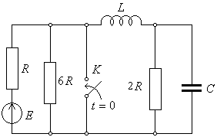
Fig. tzp. 26
R:$i_{L}(t)=6\text{.}4e^{−\text{200}t}+0\text{.}4e^{−\text{800}t}$ ; $u_{C}(t)=\text{80}e^{−\text{200}t}−\text{20}e^{−\text{800}t}$

tzp. 27.Let’s consider the circuit from Fig. tzp.27, where the values of the circuit elements are R = 5 Ω, L = 62.5 mH and C = 100 μF, and the value of the voltage source is E = 90 V. If at the momentt = 0 the switch K is closed, determine the time variation of the current through the coil and of the voltage on the capacitor after switching.
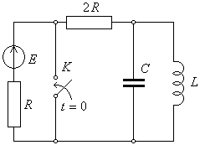
Fig. tzp. 27
R: $i_{L}(t)=8e^{−\text{200}t}−2e^{−\text{800}t}$ ; $u_{C}(t)=−\text{100}e^{−\text{200}t}+\text{100}e^{−\text{800}t}$

tzp. 28.Let’s consider the circuit from Fig. tzp.28, K moves from pozition a) to pozition b) and the values of the voltage sources are: E = E₀ (constant), respectively e(t) = 2Esinωt. If at the moment$t_{0}=\text{nT}+\frac{T}{4}$, (ωT = 2π, n very big) the switch K is open, determine the time variation of the current through the coil and of the voltage on the capacitor after switching.
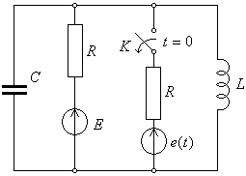
Fig. tzp. 28
R: $i_{L}(t)=\frac{E}{R}\left[1+\frac{2}{\sqrt{3}}e^{−0\text{.}5 ω t}\text{sin}\left(\frac{\sqrt{3}}{2}ωt\right)\right]$; $u_{C}(t)=\frac{2E}{\sqrt{3}}e^{−0\text{.}5 ω t}\text{sin}\left(\frac{\sqrt{3}}{2}ωt+\frac{π}{6}\right)$.

tzp. 29.Let’s consider the circuit from Fig. tzp.29, where $ωL=1/ωC=R$ and the values of the voltage sources are: E₀ = 2E (constant), respectively e(t) = 4Esinωt. If at the moment$t_{0}=\text{nT}+\frac{T}{4}$, (ωT = 2π, n very big) the switch K K moves from pozition a) to pozition b) determine the time variation a of the current through the coil and of the voltage on the capacitor after switching.
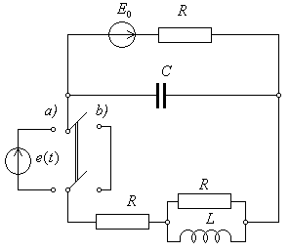
Fig. tzp. 29
R : $i_{L}(t)=\frac{E}{R}\left(1−e^{− ω t}\right)$; $u_{C}(t)=E\left(1−e^{− ω t}\right)$

tzp. 30.Let’s consider the circuit from Fig. tzp30 where $R=\sqrt{L/C}=\text{10}$ Ω, L = 10 mH, C = 100 μF and the values of the voltage sources are: E = 20 V (constant), respectively e(t) = 20sinωt cu ω = 1000 rad/s. If at the moment t =0, the switch K₁ is open, and K₂ is closed, determine the time variation a of the current through the coil and of the voltage on the capacitor after switching.
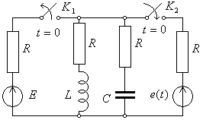
Fig. tzp. 30
R: $i_{L}(t)=\frac{3}{2}e^{−\text{1000} t}+\frac{\sqrt{2}}{2}\text{sin}\left(\text{1000}t−\frac{π}{4}\right)$; $u_{C}(t)=\text{15}e^{−\text{1000} t}+5\sqrt{2}\text{sin}\left(\text{1000}t−\frac{π}{4}\right)$

tzp. 31.Let’s consider the circuit from Fig. tzp.31 where R = 1 Ω, R₁ = 10 Ω, L = 100/π mH, C = 1/π mF and the values of the voltage sources are:: E₀ = 200 V (constant), respectively e(t) = 10sinωt cu ω = 100π rad/s. If at the momentt = 0, the switch K moves from pozition a) to pozition b) determine the time variation of the current through the coil and of the voltage on the capacitor after switching.
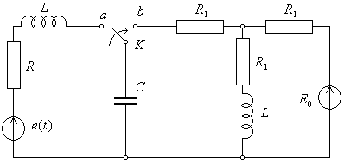
Fig. tzp. 31
R: i_{L}(t) = 10 – 1000π ⋅te ^{–100π t} ; u_{C}(t) = 100 – 200(1 + 50π ⋅t)e ^{–100π t}

tzp. 32.Let’s consider the circuit from Fig. tzp.32 where R = 10 Ω, L₁ = 40 mH, L₂ = 20 mH, L = 250/3 mH C = 200 μF and the values of the voltage sources are: E = 100 V (constant), respectively e(t) = 100 + 200sin500t. If at the momentt = 0, the switch K moves from pozition a) to pozition b) determine the time variation of the current through the coil L and of the voltage on the capacitor after switching.
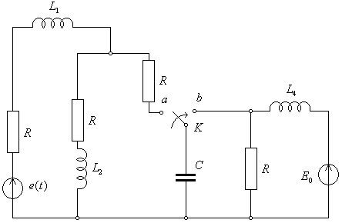
Fig. tzp. 32
R: $i_{L}(t)=\text{10}+\text{12}e^{−\text{200}t}−\text{12}e^{−\text{300}t}$; $u_{C}(t)=\text{100}+\text{200}e^{−\text{200}t}−\text{300}e^{−\text{300}t}$

